

**Course Code :** CSE 347

**Course Title :** Information System Analysis and Design

**Semester :** Summer 25

**Section:** 01

**Group :** 01

**Submitted to :**

Dr. Shamim H Ripon

Professor

Department of Computer Science & Engineering

**Submitted by:**

| **Student ID** | **Student Name** | **Contribution Percentage** |
| --- | --- | --- |
| 2023-1-60-112 | Md Fokrul Akon | 45% |
| 2023-1-60-006 | Rejaul Karim Sohag | 35% |
| 2022-3-60-210 | Md Moon Rahman Nayem | 20% |
| 2023-1-60-079 | Erin Reza | 00% |

# 

# Table of Contents

**Table of Contents** **2**

**1. Introduction** **3**

**2. Project Overview** **4**

2.1 Project Description: 5

2.2 Project Scope and Boundaries: 5

2.3 Purpose and Objectives of the Project: 6

**3. Stakeholders and Actors** **6**

3.1 Key Stakeholders: 7

**4. Project Requirements** **9**

4.1 Functional Requirements 9

4.2 Non-Functional Requirements 10

4.3 Technical Requirements 11

4.4 Business Requirements 12

**5. Resource Management** **12**

5.1 Team Members and Their Roles 12

5.2 Tools, Technologies, and Resources 13

5.3 Hardware and Hosting Resources 13

**6. Risk Management** **14**

6.1 Identify Potential Risks 14

6.2 Risk Mitigation Strategies 14

6.3 Risk Assessment Matrix 15

**7. Quality Management** **15**

7.1 Quality Assurance Processes 15

7.2 Evaluation Criteria 15

7.3 Monitoring and Controlling Quality 16

**8. Communication Plan** **16**

8.1 Communication Channels 16

8.2 Reporting Frequency 17

8.3 Documentation 17

**9. Conclusion** **17**

# 1. Introduction

In the modern digital world, managing employees and tasks efficiently is very important. Many companies, especially those with many employees and tasks, face difficulties in managing daily activities. Without a proper system, work can become unorganized, tasks may be forgotten or missed, and productivity can go down, leading to stress, confusion & poor performance.

Our project, "TaskVista – Employee Task Management System," aims to solve this problem. We want to create a system where managers can easily assign tasks, and employees can clearly see how they will manage everything and how they need to do everything. The system will also allow tracking of employee’s task progress, attendance, performance, productivity and enhancing overall workplace efficiency.

Before starting a project like this, it is important to gather requirements and plan everything in detail. Good planning ensures that the system meets the needs of users and avoids mistakes during development. This report will explain how we gathered requirements, who is involved in the project, what features we will build, and presents our strategy of how we plan to finish the project successfully.

We visited three companies—Swadesh Pratidin, Promee International, and HS Corporation , Impulse Ocean View —to understand what kind of system they need. All of them want a user-friendly interface that is easy to understand and use. Based on their feedback, we planned the main features of the system and created a step-by-step development plan.

Task management systems help organizations keep work organized and improve communication. Manual methods often lead to errors, miscommunications and lost time. Our system will automate many processes to reduce these problems.

Managers will be able to assign tasks quickly and monitor their progress. Employees will receive notifications about deadlines and updates. The attendance feature will help keep accurate records easily.

TaskVista, is designed to automate and streamline these processes, reducing inefficiencies and enhancing team coordination.

Key features of the system include:

· Efficient task assignment and tracking for managers.

· Real-time notifications for employees regarding deadlines and task updates.

· An attendance tracking module for maintaining accurate and accessible records.

· Role-based access control, ensuring that sensitive data is only available to authorized users such as admins, while employees have access to relevant information.

Security is important, so the system will give different access levels to admins and employees. This protects sensitive information and prevents confusion.

Our design focuses on simplicity and usability, making it easy for users with different technical skills. Regular feedback from clients will help improve the system throughout development.

By using TaskVista, companies can increase productivity and reduce administrative work. Employees will better understand their tasks and deadlines.

We will also ensure the system can grow with the organization’s needs. Testing and quality checks will help deliver a reliable product.

In summary, this project aims to provide an efficient, user-friendly task management system. The following sections will explain the project details and how we plan to complete it successfully.

# 2. Project Overview

This section provides a detailed overview of our proposed system, TaskVista. It includes the project title, a short and meaningful description, the scope and boundaries of the project, and the main goals and expected results.

**Project Title:** **TaskVista – Employee Task Management System**

## 2.1 Project Description:

TaskVista is a web-based application designed to help organizations efficiently manage tasks and monitor employee performance. It provides an interactive dashboard for administrators to assign tasks, track progress, and handle attendance records. Employees can view their assigned tasks, submit progress updates, and manage their profiles.

The system offers two user roles: Admin and Employee. Admins have full control over the system’s functionalities, including task creation, employee management, and performance analysis. Employees, on the other hand, have limited access focused on their individual responsibilities and daily updates. The system supports real-time updates and automated notifications to ensure smoother communication and better collaboration across teams.

TaskVista will also include analytics features that provide performance summaries, task completion rates, and time tracking data to help management make more informed decisions. These insights can be visualized through graphs and reports, helping identify trends and areas for improvement.

A standard, user-friendly interface will make the system accessible even to users with limited technical knowledge. The responsive design ensures usability across different devices, including desktops, tablets, and smartphones. Security and data privacy will also be prioritized, with features like role-based access and secure login mechanisms.

## 2.2 Project Scope and Boundaries:

Understanding what is included in the project and what is not is crucial to avoid confusion during development. The scope defines the core features and limitations of the TaskVista system.

Included Features:

* User registration and login functionality
* Admin dashboard for task management
* Employee dashboard for task tracking
* Attendance submission and tracking
* Notifications and reminders for tasks
* Profile management (edit/update personal info)
* Role-based access control (Admin vs Employee)
* Simple reporting and task analytics

Excluded Features:

* Integration with payroll systems or external HR modules
* Mobile application version (only web-based)
* Multi-language support (Bangla interface may be considered in the future)
* Real-time chat or messaging

## 2.3 Purpose and Objectives of the Project:

The purpose of TaskVista is to improve how organizations manage tasks, monitor attendance, and track employee productivity. In Bangladesh, many small and medium-sized enterprises (SMEs) still rely on manual or semi-automated systems, which are often time-consuming, inefficient, and prone to errors. These outdated methods can lead to missed deadlines, miscommunication, and reduced overall performance. Through this project, we aim to provide these organizations with a more reliable, user-friendly, and automated solution that helps streamline operations, save time, and enhance workplace productivity.

Main Objectives:

* To build a task management system with a user-friendly interface
* To automate the task assignment and tracking process
* To ensure accurate and easy attendance submission
* To provide clear visibility of work progress to management
* To help employees understand their responsibilities better
* To generate insights through simple reporting tools

By achieving these objectives, TaskVista will add real value to client companies. It will save time, reduce mistakes, and allow managers to focus on decision-making rather than paperwork.

In the next section, we will explore the stakeholders involved in the project and describe their roles and responsibilities in more detail.

# 3. Stakeholders and Actors

In any project, identifying stakeholders and clearly defining their roles is essential for ensuring smooth development and successful delivery. For TaskVista, we have identified several key stakeholders based on the project scope, client feedback, and organizational needs. Each stakeholder plays a specific role in guiding the project, contributing to its progress, and ensuring that the final product meets user expectations.

## 3.1 Key Stakeholders:

1. **Admin (Manager):**

* Responsible for creating and assigning tasks.
* Monitoring task progress and employee attendance.
* Generating reports and analytics.
* Managing system users and roles.

1. **Employee (User):**

* Receives task assignments.
* Updates task status and progress.
* Submits attendance records.
* Manages personal profile information.

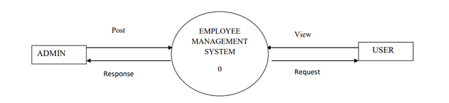

**Figure-01**

1. **Project Development Team:**

* Responsible for system design, development, testing, and deployment.
* Ensures that the project meets requirements and quality standards.

1. **Client Organizations:**

* Companies like Swadesh Pratidin, Promee International, and HS Corporation.
* Provide initial requirements and feedback.
* Validate system functionality during testing.

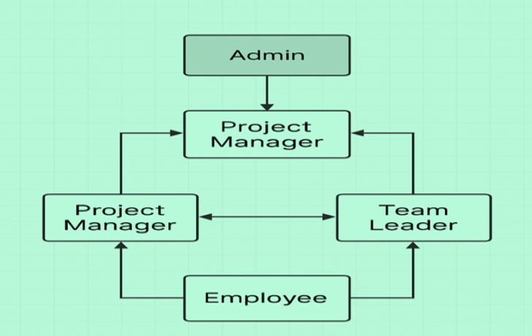

**Figure-02: Stakeholder Interaction Diagram**

**Roles and Responsibilities:**

| **Stakeholder Role** | **Description** |
| --- | --- |
| Admin | Manages tasks, users, attendance, and overall system administration. |
| Employee | Executes tasks assigned, updates progress, and maintains attendance. |
| Development Team | Designs and builds the system according to requirements and specifications. |
| Client Organizations | Provide domain knowledge, requirements, and validate the final system. |

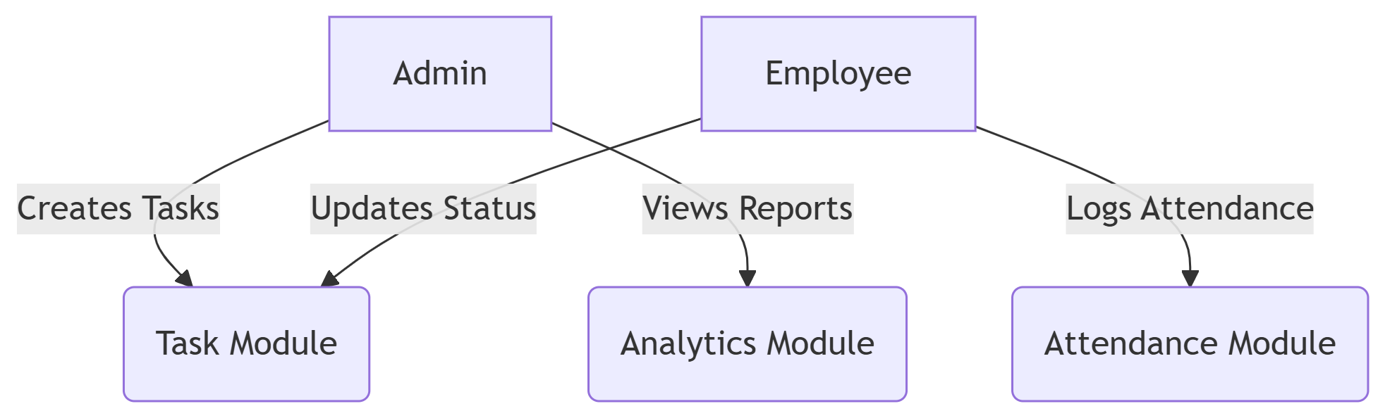

**Figure-03**

Clear communication and defined responsibilities among stakeholders will ensure the project progresses smoothly and meets its objectives

# 4. Project Requirements

This section outlines the key requirements gathered for the TaskVista system. Requirements are divided into four categories: functional, non-functional, technical, and business. Understanding these requirements is essential to designing a system that meets stakeholder expectations and operates efficiently.

## 4.1 Functional Requirements

Functional requirements define the core features and behaviors the system must support. For TaskVista, the main functionalities include:

* **User Registration and Login:**  
  Users (Admins and Employees) must be able to register and securely log into the system.
* **Role-Based Access Control:**  
  The system must restrict access based on roles, providing Admins with full privileges and Employees with limited rights.
* **Task Management:**  
  Admins should be able to create, edit, assign, and delete tasks. Employees can view assigned tasks and update their status.
* **Dashboard:**  
  Both Admins and Employees should have dashboards showing relevant information such as task summaries and attendance status.
* **Attendance Tracking:**  
  Employees must be able to submit daily attendance, and Admins should monitor and manage attendance records.
* **Notification System:**  
  The system should send reminders and alerts for new tasks, deadlines, and attendance submissions.
* **Profile Management:**  
  Users should be able to view and update their personal profile information.

## 4.2 Non-Functional Requirements

Non-functional requirements describe how the system performs and behaves under certain conditions:

* **Usability:**  
  The system must have a clean, intuitive, and user-friendly interface, ensuring ease of use even for non-technical users.
* **Reliability:**  
  The system should operate consistently without crashes or data loss.

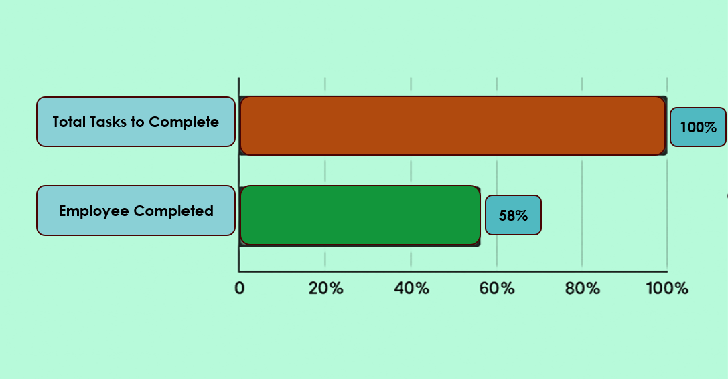

**Figure 04: Task Completion Gantt Chart Showing Assigned vs Completed Work Percentage**

* **Performance:**  
  Task and attendance operations should be processed quickly with minimal delay.
* **Scalability:**  
  The system should support growth in the number of users and tasks without performance degradation.
* **Security:**  
  User data must be protected through secure authentication and authorization mechanisms.

## 4.3 Technical Requirements

* **Backend Technology:** PHP (Laravel Framework recommended) for robust server-side development.
* **Frontend Technology:** HTML, CSS, JavaScript (using Bootstrap or React for responsive UI).
* **Database:** MySQL for data storage and management.
* **Hosting Environment:** Shared or cloud-based hosting with support for PHP and MySQL.
* **Version Control:** Git for code management and collaboration.

## 4.4 Business Requirements

* **Deployment Timeline:** The system should be completed and ready for deployment by mid-August 2025.
* **Cost Efficiency:** The solution should be cost-effective for small to medium-sized enterprises.
* **Maintenance:** The system should require minimal ongoing maintenance and support.
* **Localization:** Optional support for the Bangla language interface to cater to local users in Bangladesh.

# **5. Resource Management**

Effective management of resources—including human, technological, and material—is essential to the success of the TaskVista project. This section outlines the team members involved, their roles, and the tools and technologies that will support project development.

## 5.1 Team Members and Their Roles

Our project team consists of three members, each responsible for specific parts of the system development:

* **Md. Fokrul Akon** – Backend Developer (PHP) – Responsible for developing the server-side logic using PHP and MySQL. Documentation Specialist – Prepares project reports, diagrams, and requirement documents.
* **Rejaul Karim Sohag** – Database Designer & Backend Support – Designs database schema, ensures data integrity, and assists in backend logic.
* **Md. Moon Rahman Nayem** – Frontend Developer  
  Develops the client-side interface using HTML, CSS, and JavaScript to implement responsive and user-friendly features.

## 5.2 Tools, Technologies, and Resources

The project will utilize various software tools and technologies to support development, collaboration, and testing:

* **Development Tools:**
  + Visual Studio Code: Primary code editor for writing and debugging code.
  + MySQL Workbench: Tool for database design and management.
  + XAMPP: Local server environment for development and testing.
* **Frameworks and Libraries:**
  + Laravel: PHP framework for backend development.
  + Bootstrap: CSS framework for responsive design.
  + JavaScript (with React, if applicable): For dynamic frontend features.
* **Collaboration and Version Control:**
  + Git and GitHub: Version control system to manage source code changes and collaboration.
* **Project Management and Communication:**
  + Trello or Jira: For task assignment and progress tracking.
  + Google Meet and Messenger: For team meetings and communication.

## 5.3 Hardware and Hosting Resources

* **Development Machines:** Each team member will use personal laptops or desktops capable of running development tools smoothly.
* **Hosting:** The final system will be deployed on a shared hosting platform supporting PHP and MySQL or on a cloud platform if budget permits.

# 6. Risk Management

Risk management is a critical part of project planning that involves identifying potential risks, assessing their impact, and developing strategies to mitigate or avoid them. For the TaskVista project, we have identified several risks that could affect the timeline, quality, or success of the system.

## 6.1 Identify Potential Risks

* **Requirement Changes:**  
  Changes or additions to requirements after development begins can cause delays and increase costs.
* **Technical Challenges:**  
  Issues with integrating different system components, bugs, or unexpected technical difficulties.
* **Resource Availability:**  
  Team members might face illness, academic workload, or other commitments that reduce their availability.
* **Time Constraints:**  
  Limited time to complete development and testing due to academic deadlines.
* **Communication Gaps:**  
  Misunderstandings between team members or with clients could lead to incorrect implementation.
* **Hardware or Software Failures:**  
  Failures in development machines or hosting servers could disrupt progress.

## 6.2 Risk Mitigation Strategies

* **Frequent Communication:**  
  Regular team meetings and updates to quickly address issues and keep everyone aligned.
* **Clear Documentation:**  
  Maintaining up-to-date requirement documents and version control to track changes.
* **Backup Plans:**  
  Assign backup roles within the team to cover for absences or emergencies.
* **Incremental Development:**  
  Developing the project in smaller parts to allow early testing and feedback.
* **Use of Reliable Tools:**  
  Choosing stable and well-supported frameworks, databases, and hosting services.

## 6.3 Risk Assessment Matrix

| **Risk** | **Likelihood** | **Impact** | **Mitigation Strategy** |
| --- | --- | --- | --- |
| Requirement Changes | Medium | High | Frequent client feedback sessions |
| Technical Challenges | High | Medium | Code reviews and testing |
| Resource Availability | Low | High | Role backup and flexible scheduling |
| Time Constraints | Medium | High | Early planning and task prioritization |
| Communication Gaps | Medium | Medium | Clear documentation and regular meetings |
| Hardware/Software Failures | Low | Medium | Regular backups and contingency plans |
|  |  |  |  |

# 7. Quality Management

Ensuring the quality of the TaskVista system is vital to meet user expectations and maintain reliability. This section explains the processes we will use to assure quality throughout the project lifecycle.

## 7.1 Quality Assurance Processes

* **Code Reviews:**  
  Team members will regularly review each other’s code to detect bugs early and maintain coding standards.
* **Testing:**  
  We will conduct multiple testing phases, including unit testing, integration testing, and user acceptance testing to validate system functionality.
* **User Feedback:**  
  Early prototypes will be shared with stakeholders to gather feedback and make necessary improvements.
* **Documentation:**  
  Maintaining clear and updated documentation for all project components to ensure maintainability and knowledge sharing.

## 7.2 Evaluation Criteria

The success of the project will be measured using the following criteria:

* **Functionality:**  
  All specified features must work as intended without errors.
* **Usability:**  
  The system should be easy to use for both admins and employees, with an intuitive interface.
* **Performance:**  
  The application should respond quickly without noticeable delays.
* **Reliability:**  
  The system should operate consistently without crashes or data loss.
* **Security:**  
  User data and access must be protected against unauthorized use.

## 7.3 Monitoring and Controlling Quality

* **Progress Tracking:**  
  Use project management tools like Trello to track task completion and issues.
* **Bug Tracking:**  
  Maintain a bug list and prioritize fixes based on severity.
* **Regular Meetings:**  
  Weekly team meetings will discuss progress, challenges, and quality concerns.
* **Stakeholder Reviews:**  
  Periodic demos and reports will be presented to clients for feedback and approval.

# 8. Communication Plan

Effective communication is key to successful project execution. The TaskVista project will use a structured communication plan to ensure clear, timely, and consistent information flow among all stakeholders.

## 8.1 Communication Channels

* **Messaging:**  
  A dedicated group on Messenger or WhatsApp used for quick team communication and updates.
* **Email:**  
  Formal communication, sharing of important documents, and meeting invitations will be done via email.
* **Video Conferencing:**  
  Google Meet or Zoom will be used for virtual meetings, discussions, and presentations.

## 8.2 Reporting Frequency

* **Weekly Internal Updates:**  
  Team members will provide progress reports and discuss issues during weekly meetings.
* **Bi-Weekly Stakeholder Reports:**  
  Updates will be shared with clients and faculty supervisors every two weeks to keep them informed of progress and receive feedback.
* **Ad-Hoc Communications:**  
  Urgent matters or changes will be communicated immediately via messaging or email.

## 8.3 Documentation

* **Requirement Documents:**  
  Detailed descriptions of system requirements will be maintained and updated as needed.
* **Design Documents:**  
  Include system architecture, database schemas, and UI wireframes.
* **Meeting Minutes:**  
  Records of discussions and decisions from meetings.
* **Final Project Report:**  
  Comprehensive documentation of the project from start to finish.
* **User Manuals:**  
  Guides to help end-users navigate and use the system effectively.

# 9. Conclusion

Thorough project planning and detailed requirement gathering are essential foundations for the success of any information system. In the TaskVista project, these processes have allowed us to understand the needs of our stakeholders, define clear objectives, and prepare a structured roadmap for development.

By engaging directly with client organizations such as Swadesh Pratidin, Promee International, and HS Corporation, we gained valuable insights into the real challenges faced in task and employee management. Their emphasis on a standard, user-friendly interface shaped our project’s core design principles.

Our detailed planning covers all critical aspects, from stakeholder roles and system requirements to resource allocation, risk mitigation, quality assurance, and communication strategies. This holistic approach ensures that the system will be reliable, usable, and aligned with business needs.

Moving forward, adhering to this plan will help the project team stay focused, manage risks proactively, and deliver a product that truly benefits the client organizations by improving task management efficiency and employee productivity.